

*A Message from Our Executive Director*

***in this issue >>>***

***current topics >>>***

*Organization Metrics*

*Lynn Edwards*

As we wrap up our first quarter, I am thrilled to share the incredible progress and success of Cuddles & Coo Diaper Pantry. In just three

Insights and remarks from some of the mothers who shared their experience through our customer survey. Also, a sneak peek into the exciting activities and initiatives we have

have accomplished together in such a short time. The support we receive allows us to make a significant impact on the lives of many families, and I am grateful for your continued trust and encouragement. In this edition of our newsletter, you will find data illustrating our growth and achievements from day one until now. Heartwarming stories from families who have benefited from our program.

babies and themselves. We will continue this vital work, inspired by the community we serve, and look forward to collaborating with you. Together, we are changing lives, One diaper at a time.

[DONATE TODAY](http://www.cuddlesandcoo.org)

months, we have witnessed a remarkable increase in referrals, as well as generous donations from individuals and organizations. These gifts, both in items and monetary support, have been vital in keeping our operations going strong. I am genuinely amazed by what we

planned. None of this would be possible without the unwavering generosity and dedication of our community. We remain steadfast in our mission to support mothers in need, providing all the essentials they require for their

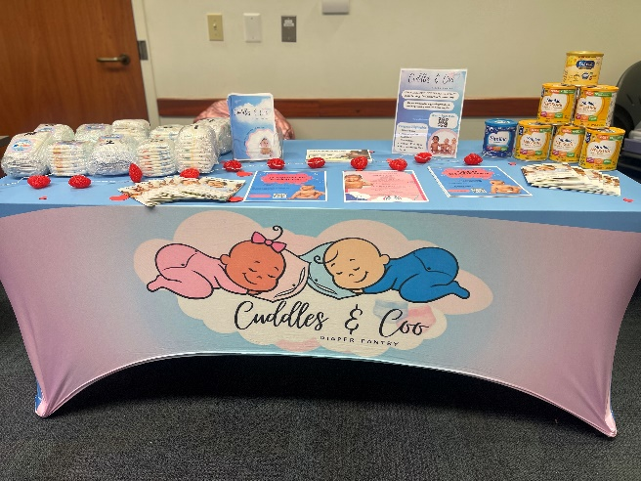

* Served approximately 50 mothers in two outreach events
* Received 41 Referrals from key areas: Lexington, Nicholasville and Lawrenceburg
* Collected over 4,000 diapers
* Distributed more than 2,000 diapers
* Accumulated a significant supply - 5,000 wipes with over 2,000 already benefiting our community.
* We have collected over 600 Pull-Ups, with 240 supporting the families we serve

**For more information go to** [**www.cuddlesandcoo.org**](https://inspirewellness-my.sharepoint.com/personal/ledwards23_humana_com/Documents/Desktop/www.cuddlesandcoo.org)

* *Organization Updates*
* *Success Stories*
* *Fundraising Efforts*
* *Upcoming Events & Outreach*
* *Team Member Spotlight*

*“I feel truly privileged to live out my passion of helping people. I am grateful to have the passion and determination that drives me to continually support the community. Every diaper donated brings hope and comfort to families in need. Together, we can make a significant impact in our community”.*

*We are proud to share our impactful achievements through our diaper pantry.*

“Together we are changing lives, one diaper at time!

***Quarter One***

**From Cuddles & Coo to You**



***Maternal Health>>>***

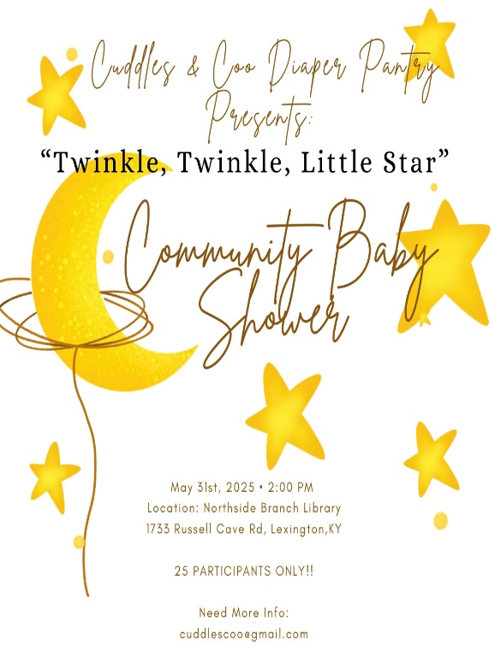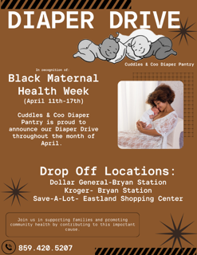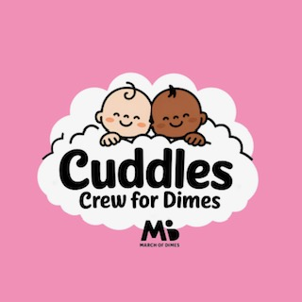

***Outreach >>>***

*Twinkle, Twinkle Little Star*

Drop off Locations:

Dollar General- 1790 Bryan Station Dr. Lexington, KY

Kroger- 1650 Bryan Station Dr. Lexington, KY

Save-A-Lot- 1301 Winchester Rd. Lexington, KY

Join us in supporting new and expecting Moms! This event aims to provide essential resources and a supportive environment for families welcoming new additions.

May 31st, 2025

2:00pm-4:00pm

Northside Branch Library

1733 Russell Cave Rd

Lexington, KY

25 PARTICIPANTS ONLY!

[REGISTER HERE](https://urldefense.com/v3/__https:/form.jotform.com/250555866704161__;!!IfVdvpvC!RiMsIjoNUcut9wkv7BUEzgfm0r-VPxzlZyh3Kobk12w0-mTW36tSiSaKYmYmu4FXFkMHW3dWsV8ZO5vvfL4n9xx9ymU$)

*Community Baby Shower*

*BLACK MATERNAL HEALTH*

Join us in supporting families and promoting community health by contributing to this important cause.

We are hosting a Diaper Drive the month of April to recognize

Black Maternal Health Week

(April 11th- April 17th)

Our Team, “Cuddles Crew for Dimes, needs help to reach our goal of $1,000. Every dollar raised goes to support the incredible work of the March of Dimes organization.

Click the link below to join our team and walk with us.

[JOIN US](https://urldefense.com/v3/__https:/form.jotform.com/250588367808168__;!!IfVdvpvC!RiMsIjoNUcut9wkv7BUEzgfm0r-VPxzlZyh3Kobk12w0-mTW36tSiSaKYmYmu4FXFkMHW3dWsV8ZO5vvfL4nNDG4mqM$)

To donate for March of Dimes, [click here](https://urldefense.com/v3/__https:/www.marchforbabies.org/Cuddles_Coo_DiaperPantry__;!!IfVdvpvC!QTSSRoS0JFJSe3ltdn8-POHZm_XAvVGpiYezQIJ8Kyu4EZYCrK6i6SBwXPLJPDmEgJ-krMODDf6AUk_cJmBzZq-FoLw$).

*We are supporting March of Dimes on Sunday May 18th, 2025, at 2pm at The Kentucky Horse Park.*

*March of Dimes: March for Babies*

**Diaper Drive at The BOLT BASH**

Join CKC 9U/10U Travel Softball and Cuddles & Coo Diaper Pantry:

Donate Diapers for a cause at the Tournament.

More details to come! Check our website for updates.



*“You’re a God sent angel, who has been there for me and Cole. I’m so grateful to have met you”- Helen E.*

In the heartwarming spirit of the holiday season, we’re excited to share the inspiring journey of Helen, a resilient mother who found hope and support through our organization, Cuddles & Coo. Referred to us by a compassionate nonprofit organization, Helen reached out seeking assistance to brighten the holidays for her young son, Cole.

*7 Ways to Support*

*Cuddles & Coo Diaper Pantry*

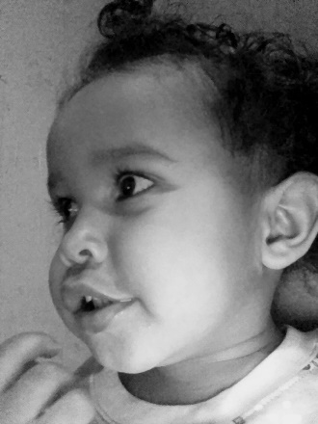

*KING’s Diaper Drive*

*Adam’s Buick, Richmond, KY*

*Join our flavorful partnership this March.*

*Pre-Order your favorite pints and be sure to select Cuddles & Coo Diaper Pantry as the beneficiary.*

[*ORDER TODAY*](https://urldefense.com/v3/__https:/cbonlinesstore.square.site/product/pints-for-a-purpose-march-2025-campaign-pre-orders-pick-up-3-21-25-3--location-/1142?cp=true&sa=false&sbp=__;!!IfVdvpvC!RiMsIjoNUcut9wkv7BUEzgfm0r-VPxzlZyh3Kobk12w0-mTW36tSiSaKYmYmu4FXFkMHW3dWsV8ZO5vvfL4nO7lPBXs$)

This story of resilience and support stands as a testament to the impact of kindness and community. At Cuddles & Coo, we are honored to have connected with Helen and elated to witness baby Cole thrive. Together, we have cultivated a bond that extends beyond simple support—it's a connection built on trust, hope, and shared dreams for a brighter future. As we continue to uplift those like Helen in our community, we remain grateful for the spirit of giving. Thank you for being part of this journey and helping create a memorable Christmas for Helen, Cole, and so many others.

Helen, mother to two-year-old Cole, faced difficult challenges including finding stable housing and losing essential items like a stroller, crucial for navigating public transportation. This was especially vital as Cole, who has cerebral palsy, requires frequent trips to the doctor. Without a stroller, these necessary journeys became even more challenging for Helen and her son.

Helen's wish list was simple yet profound: to provide a warm Christmas dinner for her family and to acquire a lightweight stroller to ease her travels with Cole. Recognizing the importance of these needs, Cuddles & Coo stepped in to provide the much-needed support. Our team was able to supply Helen not only with diapers and wipes but also made her wish come true with a fulfilling Christmas dinner and the stroller that would change their daily life for the better.

Helen's gratitude for our organization runs deep. She often refers to Cuddles & Coo as a "godsend angel" for the hope and assistance provided during her time of need. Her voice and advocacy have only strengthened, as she passionately shares the difference made in her and Cole’s lives, inspiring others in her community to reach out for support.

1. Like or follow us on Facebook and Instagram
2. Invite your Friends to Like our Facebook Page
3. Sign Up for Our Email Blast
4. Host a Diaper Drive
5. Shop from Our Amazon Wish List
6. Donate items to our organization
7. Donate Financially

The KING himself, along with Adams Buick GMC, will be collecting donations for Cuddles & Coo in Richmond, KY. You can drop-off all donations at Adams Buick GMC, located at 1017 Berea Rd, Richmond, KY.

This drive is expected to continue throughout the entire month of March.

*A Christmas to Remember: Helen’s Story*

[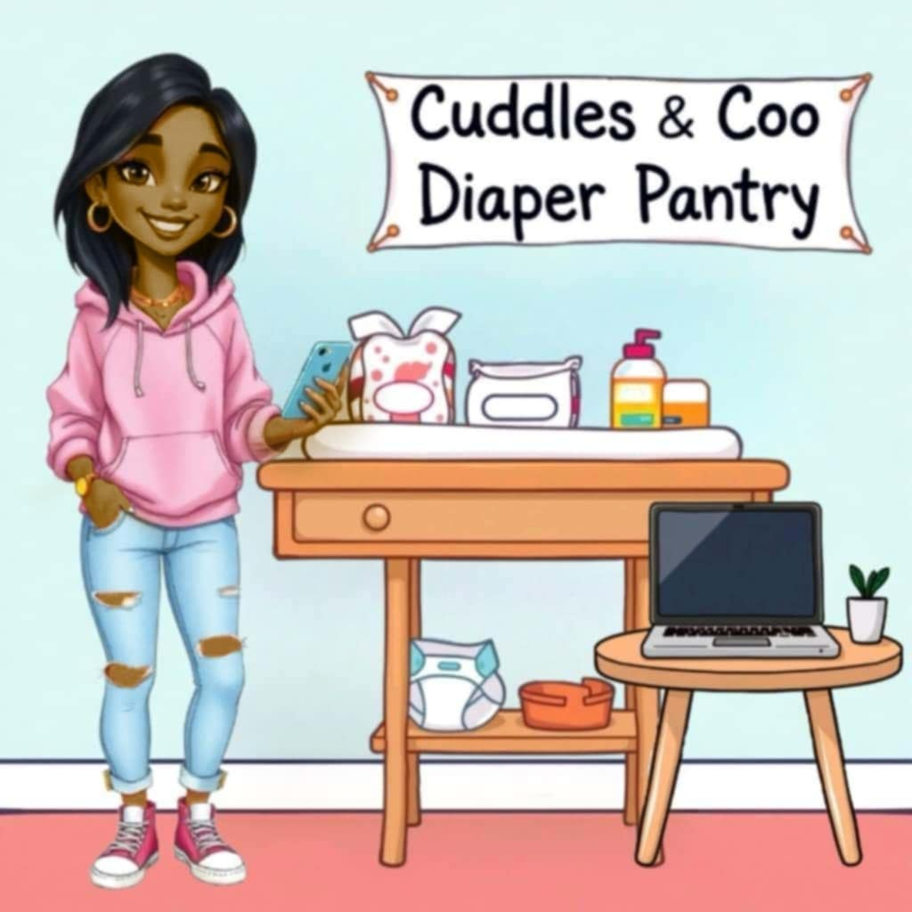](https://www.layoutready.com/?utm_source=microsoft&utm_medium=file&utm_campaign=office_online)gjhgj

Contact us at **859-420-5207**

[www.cuddlesandcoo.org](http://www.cuddlesandcoo.org)

DIAPER PANTRY

Cuddles & Coo

P.O Box: 54373 Lexington, KY 40555

DONATE TODAY

WE ACCEPT PAYMENTS VIA:

CASH APP, PAYPAL OR VENMO

CASH APP: $CuddlesCoo

PAYPAL: @CuddlesCoo

VENMO: @Cuddles-Coo

* *Community Support Efforts*
* *Managed Care Organization (MCO) Highlights*
* *Joslynn’s Bundles of Joy Nominee Recognition*
* *Monthly Workshop Schedule*
* *Mom’s Day Out Highlights*
* *Community Baby Shower Results*

*“I think Cuddles & Coo is doing incredible work for the community. I believe their efforts are truly making a positive impact. They are providing essential support and resources to those in need, and the dedication to the community is commendable”* **Monique Carter, Secretary**

***spotlight...***

*Team Member*

meeting agendas and accurately recoding minutes. Monique ensures that all documentation is meticulously filed and organized for easy access, and she diligently oversees that all actions align with the organization’s bylaws.

We are pleased to have Monique on board as our secretary. Her leadership, knowledge, and innovative ideas, along with her valuable suggestions, will greatly enhance our team.

[DONATE HERE](http://www.cuddlesandcoo.org)

*Finding An Agent That’s Right For You*

Monique Carter, our secretary at Cuddles & Coo-holds a bachelor’s degree in health service administration from EKU. She has been instrumental in promoting leadership and development as part of the Blacks United in Leadership & Development Initiative (BUILD) within her company. Over the past 6 years, Monique has actively participated in the Growing Opportunities for Women (GROW) network, contributing to its mission of empowering women. In her role at Cuddles & Coo, she is responsible for distributing

***coming soon >>>***

*In The Next Issue*